**A Cyber Security Project**

**Report**

**On**

**LOCAL FILE INCLUSION**



**DEPARTMENT OF COMPUTER SCIENCE AND ENGINEERING**

**SRKR ENGINEERING COLLEGE (A)**

Chinna Amiram, Bhimavaram, West Godavari District,pin code-534204.

**GUIDE :**

**MR.KARTHEEK CHANDA**

**SUBMITTED BY :**

**PAPASANI VENKATA RAVINDRA REDDY**   **20B91A05M1**

**PUVVADA NAGENDRA SAI KIRANU 20B91A05P9**

**RAVURI MARTIN MADHAV 20B91A05Q2**

**SARIKOKKULA SALOMAN RAJU 20B91A05R3**

**SHAIK RIZWAN AHMED 20B91A05R9**

PROJECT OUTLINE

**PURPOSE:**

Local File Inclusion (LFI) allows an attacker to include files on a server through the web browser.This vulnerability exists when a web application includes a file without correctly sanitizing the input .This allows attackers to manipulate the content of the files, stealing Sensitive data etc.This may leads to website breakdown by pulling the customers live into risk.

**GOAL:**

Our aim is to show how file inclusion can be done through various approaches and to avoid this Vulnerability by taking some control measures.

ABSTRACT

**Local File Inclusion**: This is one of the IDOR vulnerabilities. Local File Inclusion (LFI) allows an attacker to include files on a server through the web browser. This vulnerability exists when a web application includes a file without correctly sanitizing the input, allowing an attacker to manipulate the input and inject [path traversal](https://www.aptive.co.uk/cybersecurity/directory-traversal-attack/) characters and include other files from the web server.

TABLE OF CONTENTS

**1. INTRODUCTION - 5**

**2. PROBLEM STATEMENT - 6**

**3. METHODOLOGY - 7**

**4. CONCLUSION - 20**

**5. REFERENCES - 21**

INTRODUCTION

An attacker can use Local File Inclusion (LFI) to trick the web application into exposing or running files on the web server. An LFI attack may lead to information disclosure, remote code execution, or even Cross-site Scripting (XSS)

Why Attackers Use File Inclusion?

* A Local File Inclusion attack is used to trick the application into exposing or running files on the server. They allow attackers to execute arbitrary commands or, if the server is misconfigured and running with high privileges, to gain access to sensitive data.

How Attackers do File Inclusion?

* These attacks typically occur when an application uses the path to a file as input. If the application treats that input as trusted, an attacker can use the local file in an include statement.

* While Local File Inclusion and Remote File Inclusion are very similar, an attacker using LFI may include only local files.

PROBLEM STATEMENT

An attacker can use Local File Inclusion (LFI) to trick the web application into exposing or running files on the web server. An LFI attack may lead to information disclosure, remote code execution, or even Cross-site Scripting (XSS)

BACKGROUND RESEARCH/ANALYSIS:

In order to show how this local file inclusion can be done.There are

many approaches to get command line access and to establish reverse connection.There are tools like lfi-suite,kadimus etc ..which are automated tools to implement Local File Inclusion.And some approaches like executing commands to get reverse connection.

RELEVANCE:

To implement Local File inclusion we can use open source tools like Lfi-suite , kadimus to get reverse connection.Different commands in different languages to establish reverse connection through burp suite.

SCOPE:

We are going to show how local file inclusion can be implemented through lfi-suite and local file inclusion on vulnerable websites like bWAPP using burp suite.

METHODOLOGY

**LFI SUITE :**

* LFI Suite is a totally automatic tool able to scan and exploit Local File Inclusion vulnerabilities using many different methods of attack, listed below.

**Features:**

* Works with Windows, Linux and OS X
* Automatic Configuration
* Automatic Update

**Provides 8 different Local File Inclusion attack modalities:**

* /proc/self/environ
* php://filter
* php://input
* /proc/self/fd
* access log
* data://
* expect://
* Tor proxy support
* Reverse Shell for Windows, Linux and OS X

OWASPBWA: This is the VM for the [Open Web Application Security Project (OWASP)](http://www.owasp.org) [Broken Web Applications](http://www.owaspbwa.org/) project. It contains many, very vulnerable web applications

IMPLEMENTATION OF LOCAL FILE INCLUSION

STEP -1:Firstly,we need to clone lfi -suite from github,then enter into lfi-suite.py.

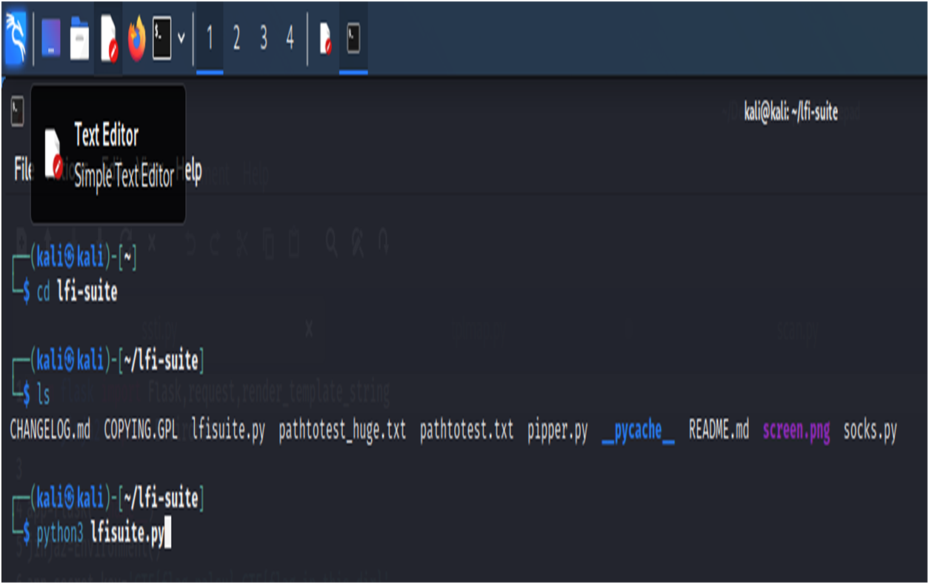

STEP-2:This is the lfi-suite interface after running the python file.

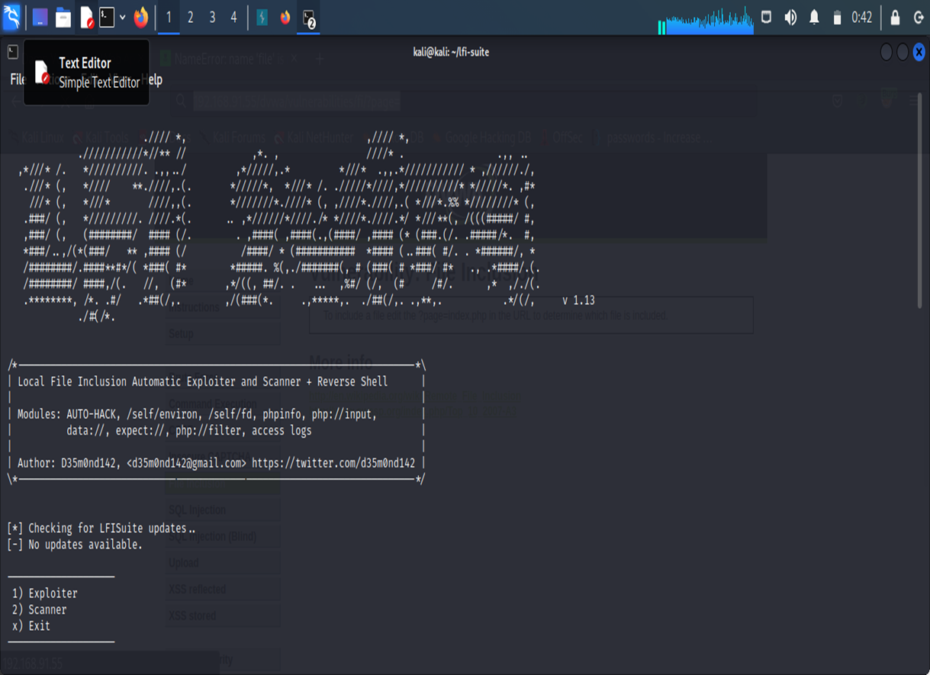

STEP-3:Now,open the owaspbwa page by entering the IP address and then enter into DVWA application.Click on file inclusion tab.

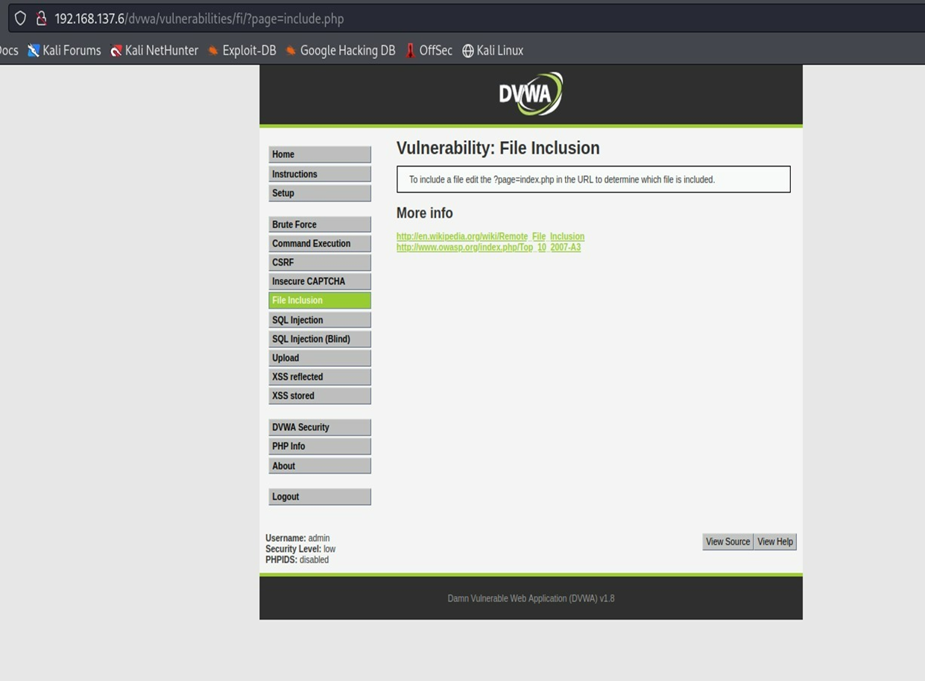

STEP-4:Now, capture the request by turning on the intercept on in burp and turning on the foxy proxy too.

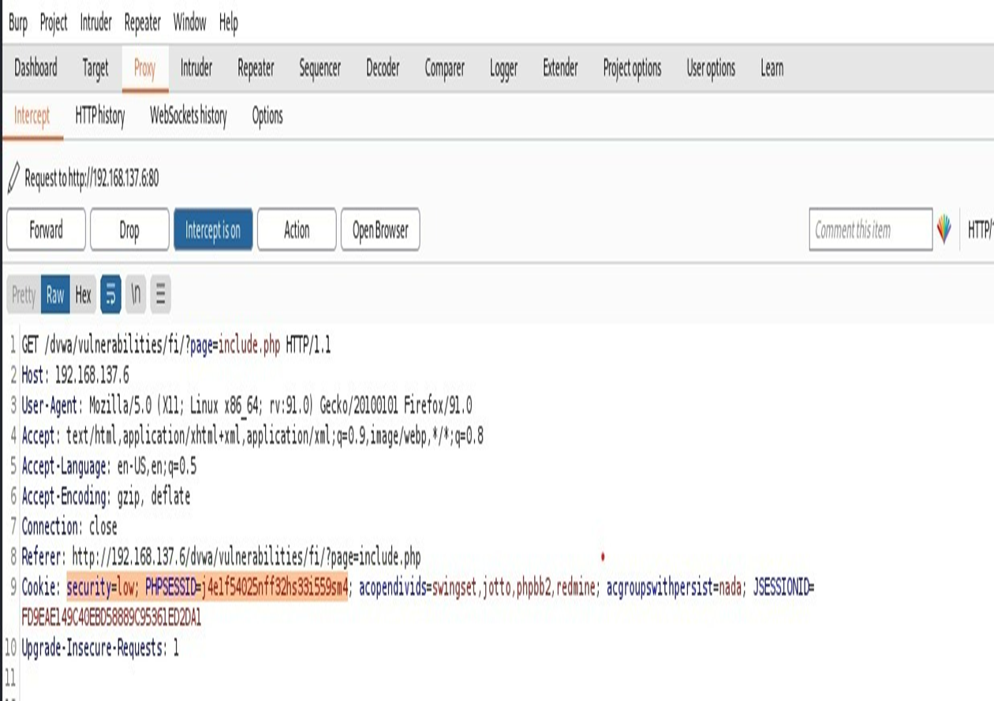STEP-5:Enter ‘1’ for exploiter ,then paste the cookie that we get in burp suite.And enter ‘n’ for no tor proxy.

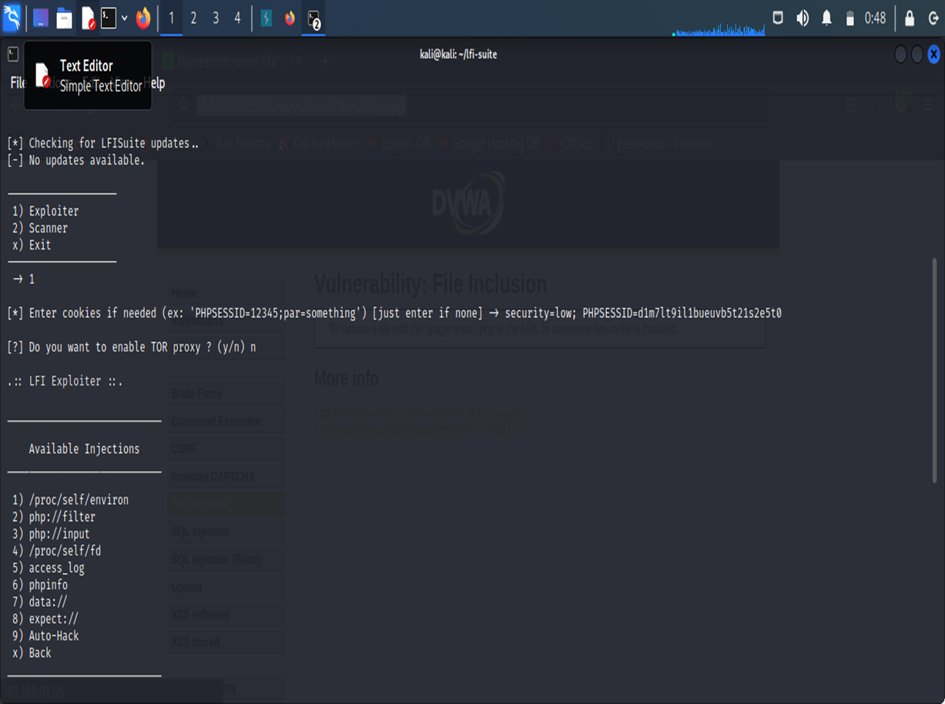

STEP-6:Enter ‘7’ for getting reverse connection.Paste the url of the vulnerable website.

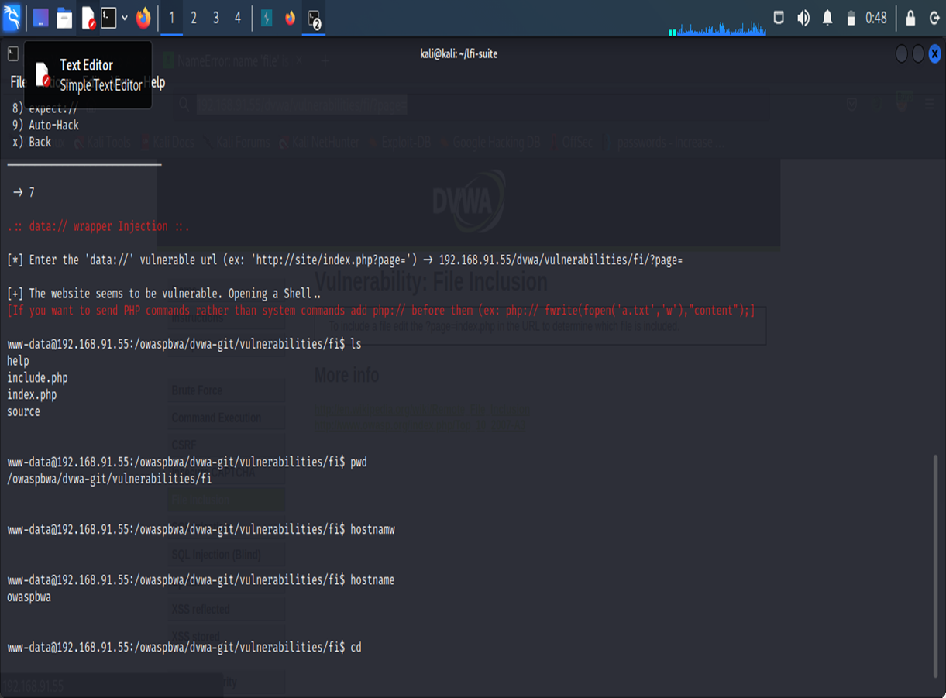

FILE INCLUSION ON bWAPP THROUGH BURP SUITE

**BURP SUITE :**

Burp or Burp Suite is a set of tools used for penetration testing of web applications. It is developed by the company named **Port swigger**, which is also the alias of its founder DafyddStuttard. Burp Suite aims to be an all in one set of tools and its capabilities can be enhanced by installing add-ons that are called BApps.

**Features:**

Target - This tool contains detailed information about your target applications, and lets you drive the process of testing for vulnerabilities.

Proxy - This is an intercepting web proxy that operates as a man-in-the-middle between the end browser and the target web application. It lets you intercept, inspect and modify the raw traffic passing in both directions.

Scanner Professional - This is an advanced web vulnerability scanner, which can automatically crawl content and audit for numerous types of vulnerabilities.

Intruder - This is a powerful tool for carrying out automated customized attacks against web applications. It is highly configurable and can be used to perform a wide range of tasks to make your testing faster and more effective.

Repeater - This is a tool for manually manipulating and reissuing individual HTTP requests, and analyzing the application's responses.

Sequencer -This is a sophisticated tool for analyzing the quality of randomness in an application's session tokens or other important data items that are intended to be unpredictable.

Decoder - This is a useful tool for performing manual or intelligent decoding and encoding of application data.

Comparer - This is a handy utility for performing a visual "diff" between any two items of data, such as pairs of similar HTTP messages.

Extender - This lets you load Burp extensions, to extend Burp's functionality using your own or third-party code.

Logger - This is a tool for recording and analyzing HTTP traffic that Burp Suite generates.

Inspector - This provides some useful features for analyzing and editing HTTP and WebSockets messages.

Collaborator client Professional - This is a tool for making use of Burp Collaborator during manual testing.

DOM Invader - This is a tool for finding DOM XSS vulnerabilities

Click bandit - This is a tool for generating Clickjacking attacks.

Mobile Assistant - This is a tool to facilitate testing of mobile apps with Burp Suite.

OWASPBWA: This is the VM for the [Open Web Application Security Project (OWASP)](http://www.owasp.org) [Broken Web Applications](http://www.owaspbwa.org/) project. It contains many, very vulnerable web applications

IMPLEMENTATION OF FILE INCLUSION ON bWAPP THROUGH

BURP SUITE

STEP-1:Open the owaspbwa page by entering the IP address,click on bWAPP application.

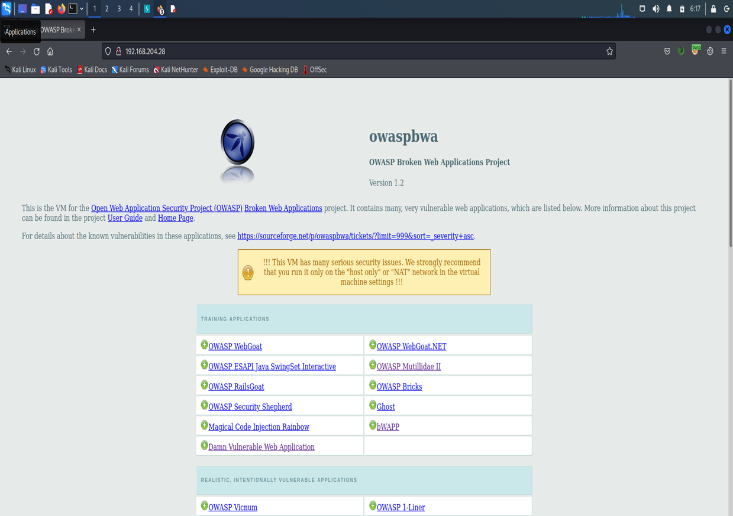

STEP-2:After entering into application .Select remote & local file inclusion.

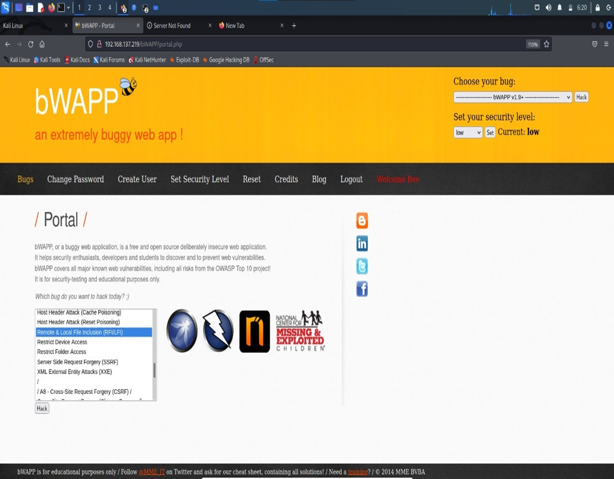

STEP -3:Turn on the foxy proxy as well as the intercept in burp suite for capturing requests.

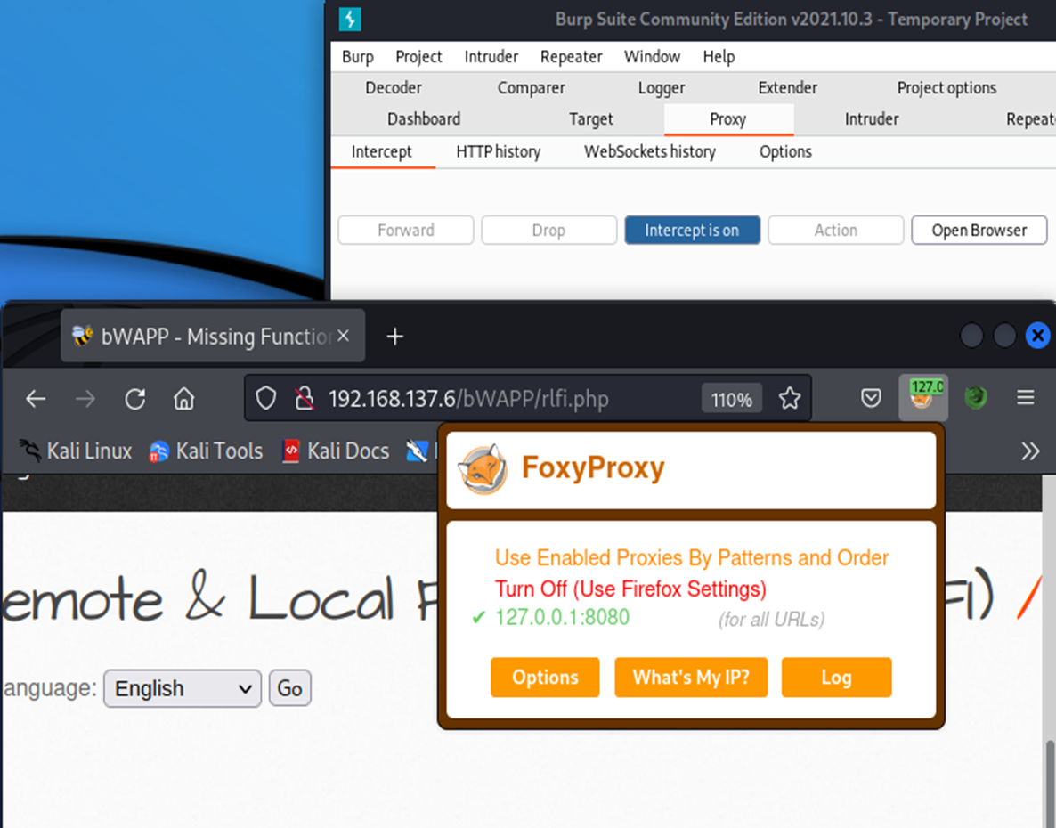

STEP- 4:Click on go.Then it redirects to the burp suite.

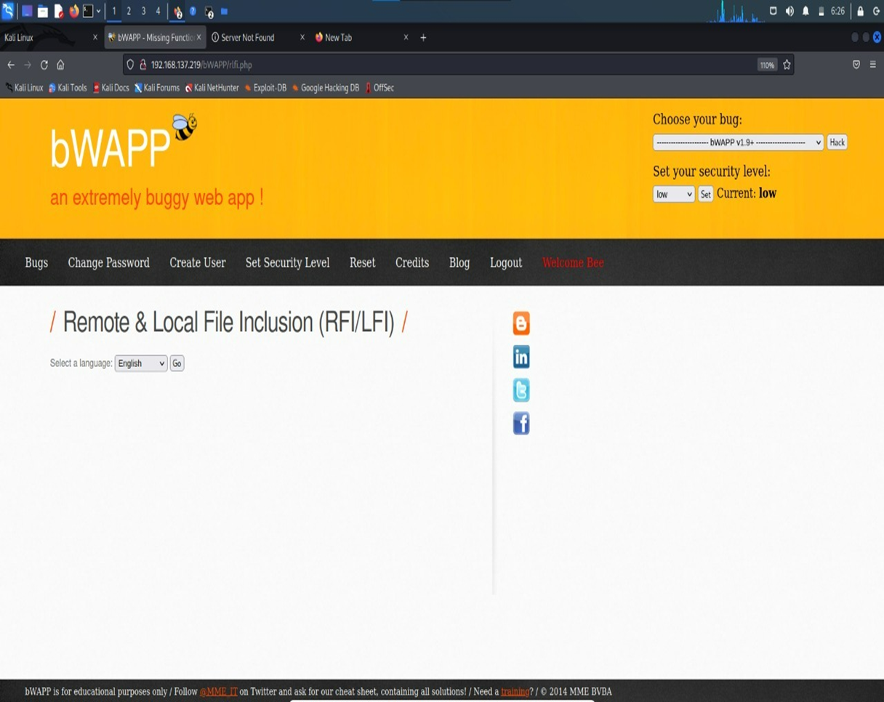

STEP -5:Send the capture request to Repeater.

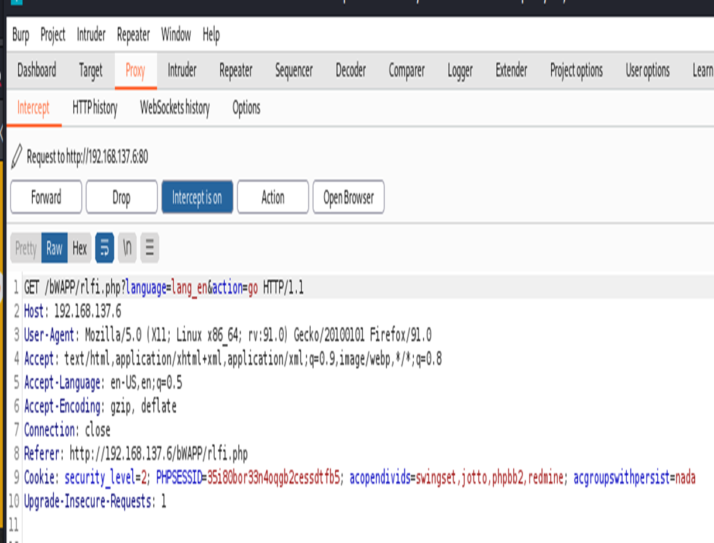

STEP -6:Enter the ‘php://input & cmd=ls’ in place of lang_en.And at the end type ‘<?php echo system($_GET[‘cmd’]); ?>’,click on send.

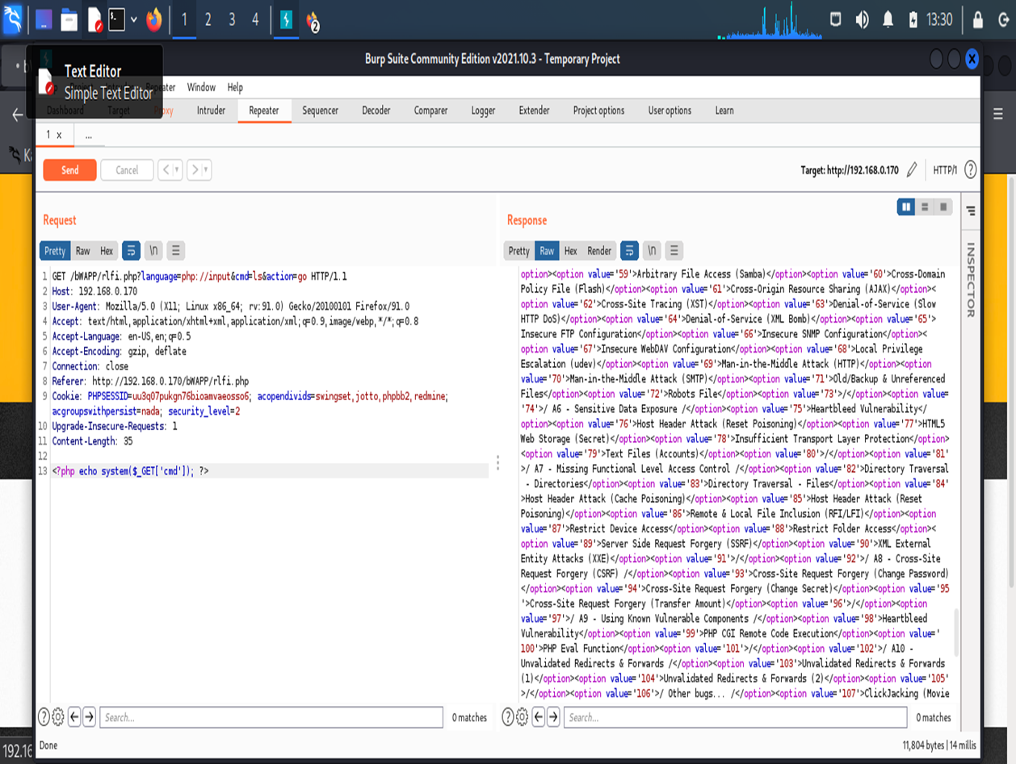STEP-7:Now modify the security level to ‘0’ to get the files present on the web server.

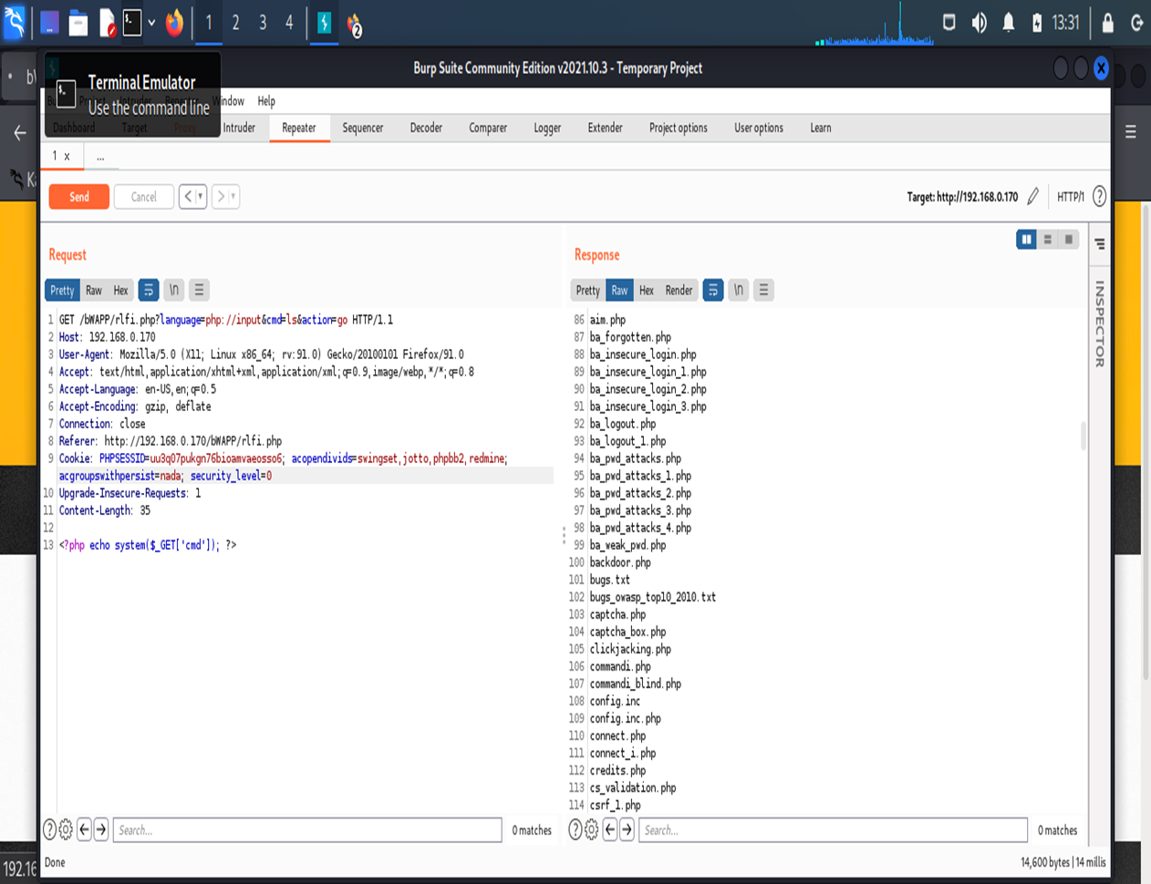

STEP-8:Enter the cmd=’which%20nc’ to get the bin files present on the web server.

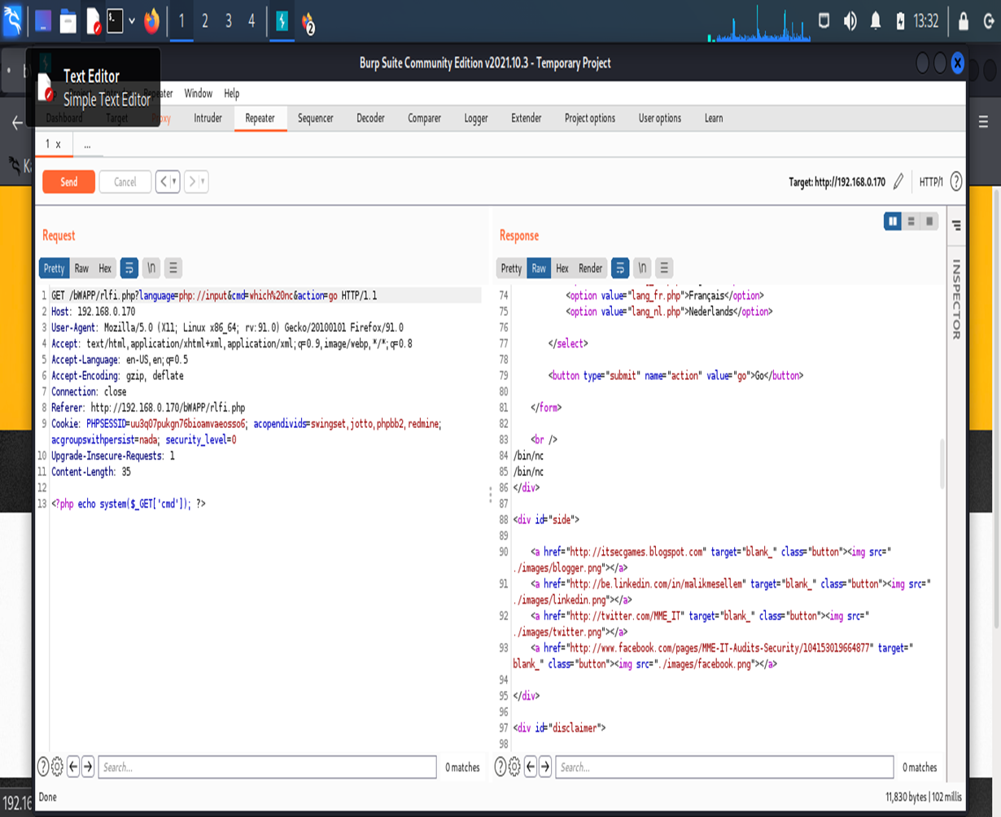STEP-9:To get a reverse connection copy the netcat command from the reverse shell cheat sheet from google.

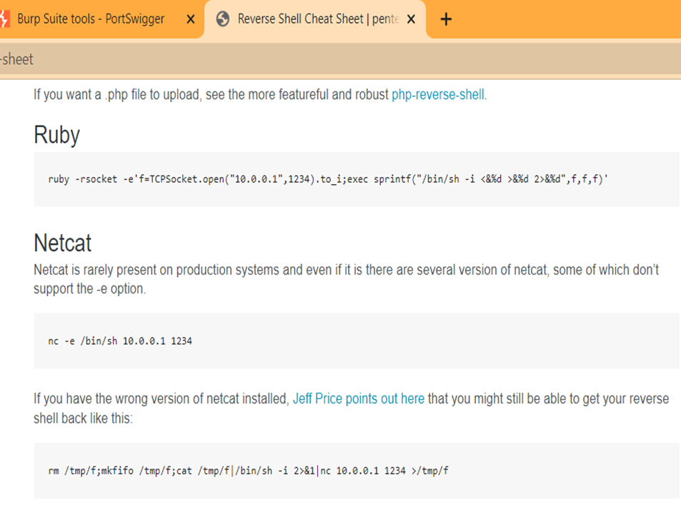

→Paste this command in place of ‘which%20nc’.Then select the command and right click and select convert selection->url->url-encode characters.

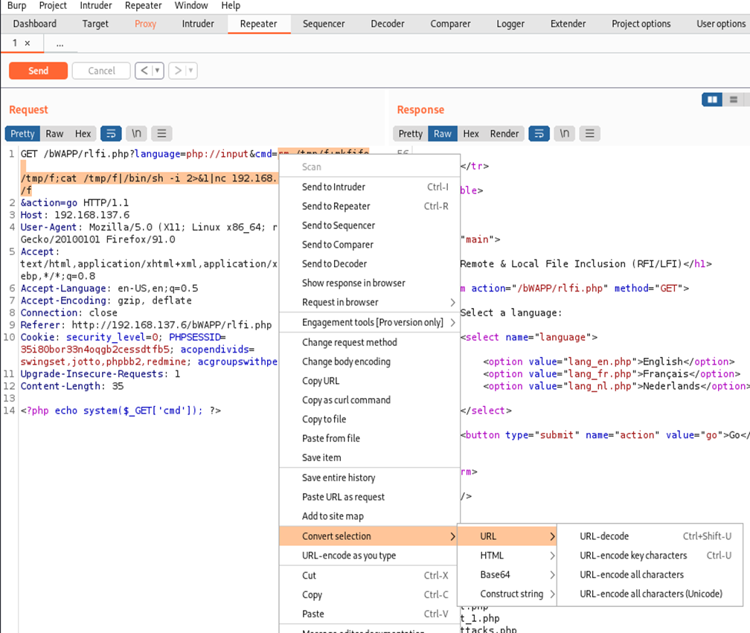

STEP-10:Before clicking on send .Turn on the listening port in the terminal.

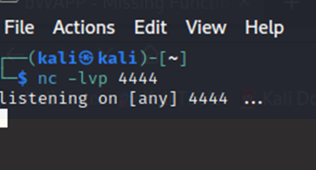

->click on the send button.

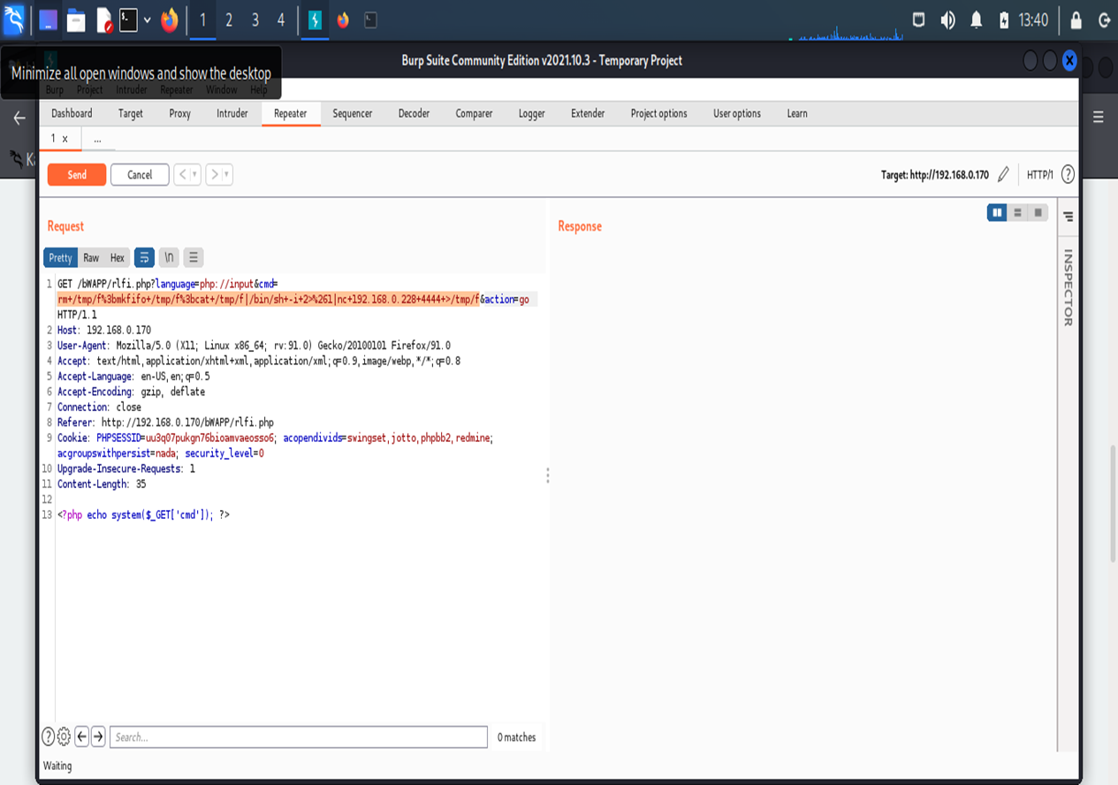

STEP- 11:Hence, Reverse connection is established.Type ‘ls’ for files in the present working directory.

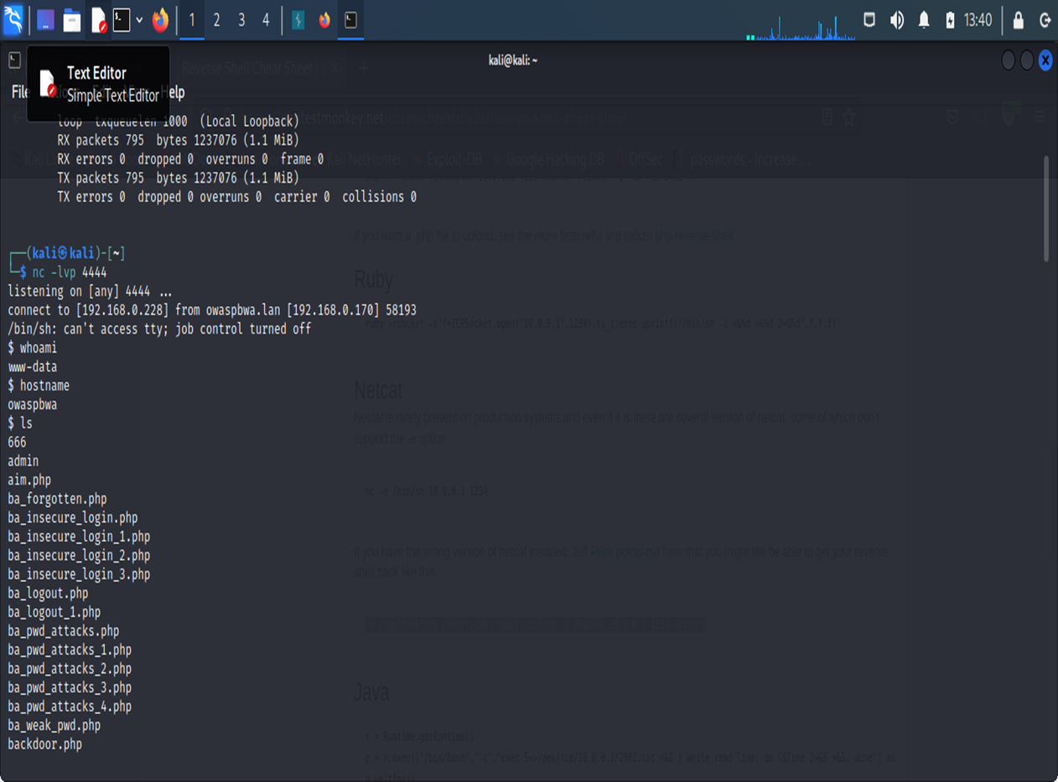

STEP-12: Type ‘whoami’ to know the filename.

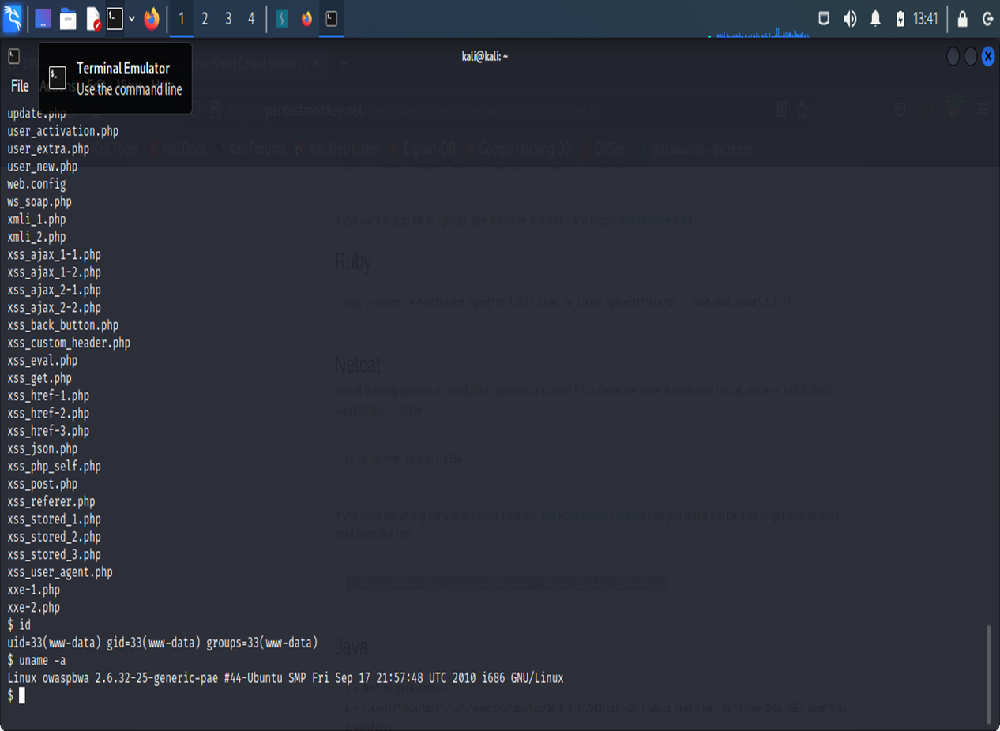

CONCLUSION:

In Summary, local file inclusion is one of the dangerous vulnerabilities.By observing from above approaches this Vulnerability puts the customers live’s into risk.This may Leads to company breakdown.There are many approaches toAchieve local file inclusion,so to avoid this there are some controlMeasures that needed to be followed.

CONTROL MEASURES:

* The most effective solution to eliminate file inclusion vulnerabilities is to avoid passing user-submitted input to any file system/framework API.
* If this is not possible the application can maintain an allowed list of files, that may be included by the page, and then use an identifier (for example the index number) to access to the selected file.
* Any request containing an invalid identifier has to be rejected, in this way there is no attack surface for malicious users to manipulate the path.

REFERENCES:

* <https://github.com/kiran-puvvada/lfi-suite>
* <https://www.youtube.com/watch?v=xQOLTUGp4MM&t=59S>
* <https://owasp.org/www-project-web-security-testing-guide/v42/4-Web_Application_Security_Testing/07-Input_Validation_Testing/11.1-Testing_for_Local_File_Inclusion>